Q1. Create EC2 instance and host any static website (like Apache or Ngnix).

Sol=>

Open AWS Management console and search for EC2 instance.

Click on EC2 instance.

Click on Launch an EC2 instance.

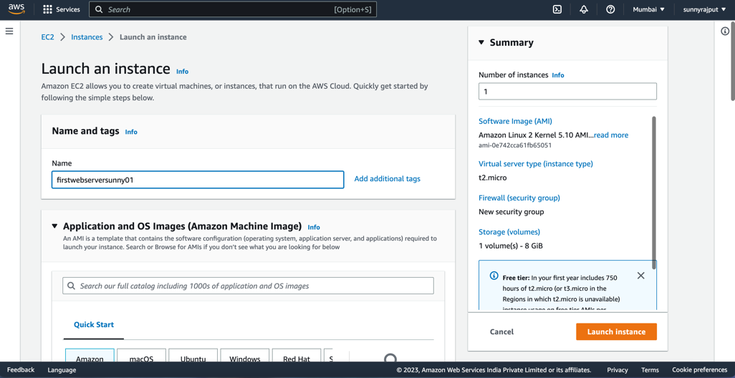

provide name and tags to the instance.

Select free tier instance type.

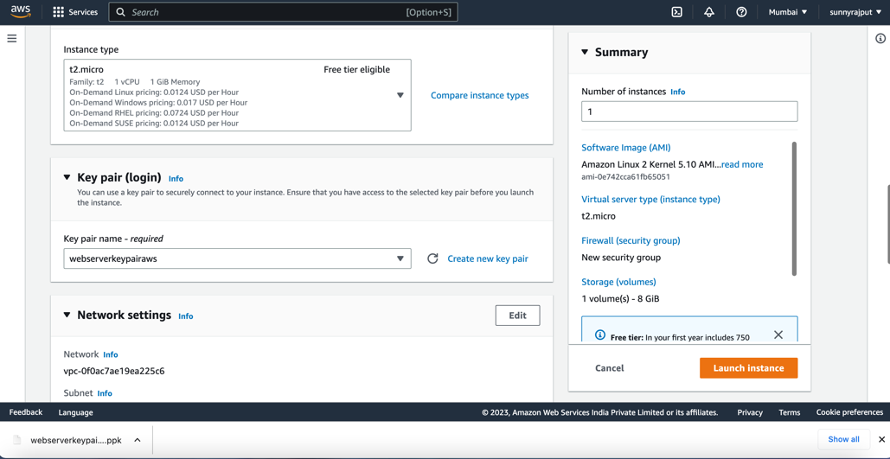

Generate key pair by clicking on create new key pair.

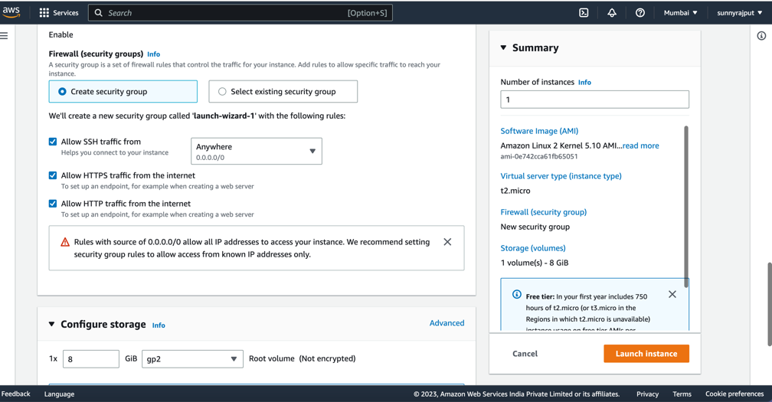

check all the https , http and ssh traffic from the internet.

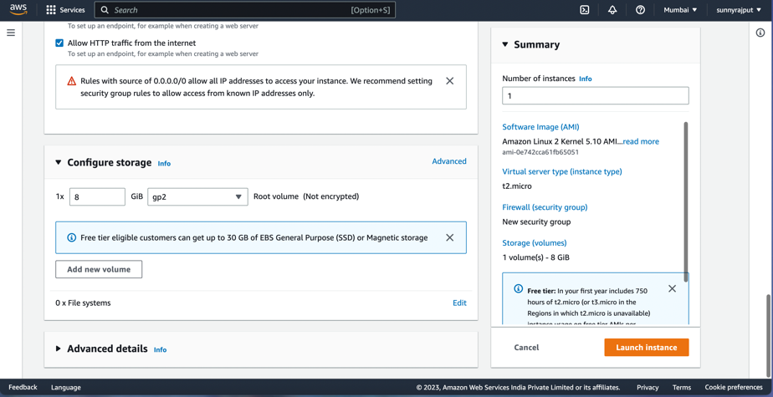

Provide appropriate storage and then launch instance.

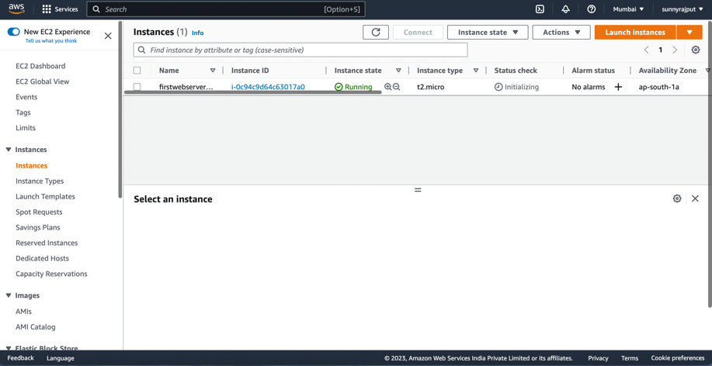

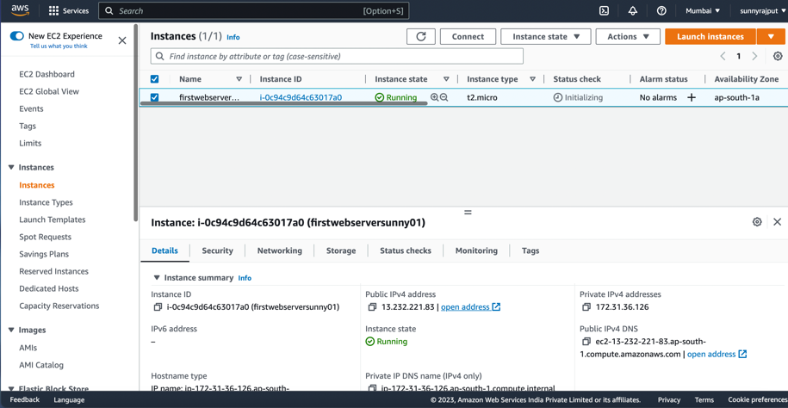

Select that instance you have created and

Check weather its running or not then run the instance

then click on connect

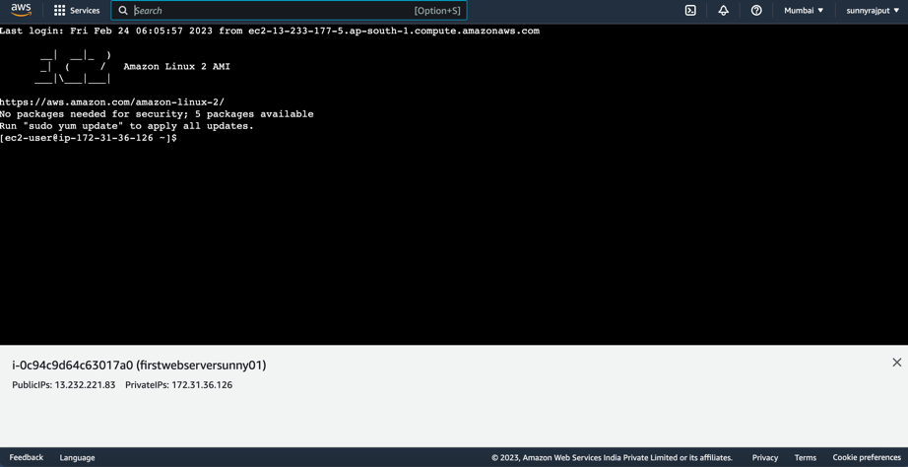

After clicking on connect a new web page terminal will open.

Then provide the following command.

Installing the Apache webserver

yum install httpd -y

Starting the webserver

service httpd start

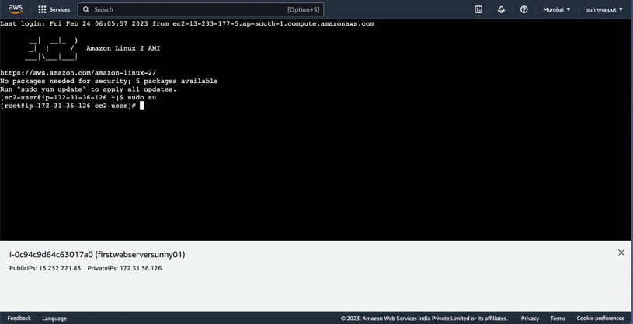

Check if the server is working or not.

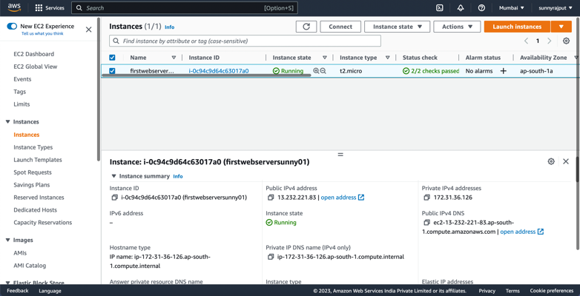

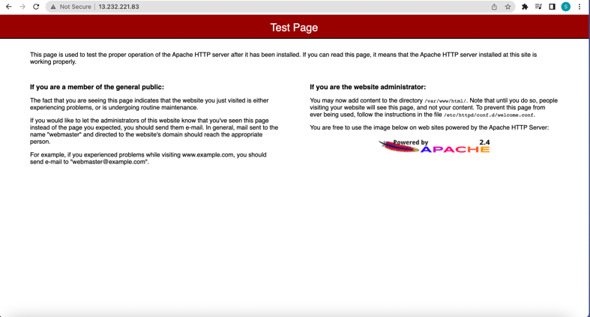

Q2. Create and connect to a SQL Server Database using Amazon RDS.

Sol=

Step1. Open the amazon RDS console.

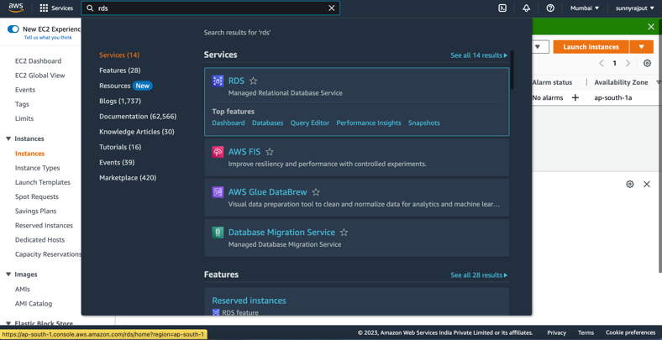

Go to the database.

Then click on create database.

Select the SQL Server database.

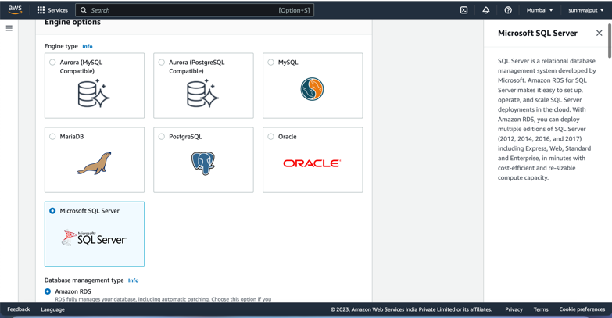

provide a name for your DB instance,

then specify a login ID and password for the master user.

Set up instance configuration and storage options.

Select a network type and configure its setting.

you need to select whether to enable Microsoft SQL Server Windows authentication or not. Next, you can get acquainted with the estimated costs.

Once done,

click Create database.

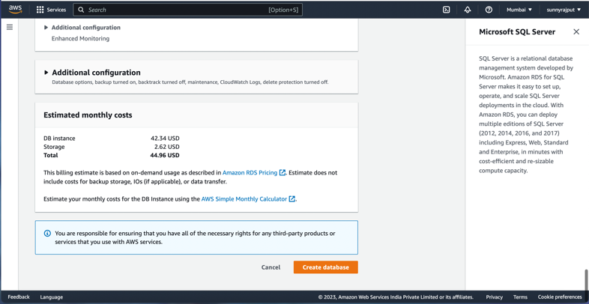

Q3. Register domain name with Amazon Route53.

Steps To register a new domain using Route 53:

1. Sign in to the AWS Management Console

2. Search and Open the Route 53 Console.

3. If you’re new to Route 53, choose Get started.

If you’re already using Route 53, in the navigation pane, choose Registered domains.

4. Choose Register Domain.

5. Enter the domain you want in the *Choose a Domain name*box And click the Check button to see if the domain is available.

6. If the domain is available, click the Add to cart button.

7. In the shopping cart, choose the number of years that you want to register the domain for.

8. Scroll to the bottom of the page to click Continue.

9. On the Contact Details for Your *n* Domains page, enter contact information for the domain registrant, administrator, and technical contacts.

10. Privacy protection: Choose whether you want to hide your contact information from WHOIS queries.

11. Choose Continue.

12. Choose whether you want us to automatically renew your domain registration before the expiration date. Review the information that you entered, read the terms of service, and select the check box to confirm that you’ve read the terms of service. Then click the Complete Purchase button.

They send an email to the registrant for the domain to verify that the registrant contact can be reached at the email address that you specified. (This is an ICANN requirement.)

You’ll receive another email when your domain registration has been approved.